**Audit and Analytics Services**

**RECONCILIATION RULE PROCEDURE**

**Contents**

Understanding Reconciliation Rule Procedure Demo 4

Overview 4

Prerequisites 5

Creating an Application 5

Creating / Viewing the Policy 7

Creating a Task 9

Enabling Reconciliation Visualization Option 10

Importing Rule Procedure 13

Deploying Rule Procedure 18

Viewing Run Status and Logs 18

**Figures**

Figure 1: Sample Report File 5

Figure 2: Applications page 5

Figure 3: Create Application screen 6

Figure 4 Entering the Name as “App1” 6

Figure 5 Enabling Lock Cycle on Advancement Check box 7

Figure 6 Tools Menu 7

Figure 7 Policy Editor Window 8

Figure 8 Browse Policy File 8

Figure 9 Policy File Selected 8

Figure 10 Edit Policy Window 9

Figure 11: Select App1 9

Figure 12: Create Folder/Task button 10

Figure 13: Create Folder/Task screen 10

Figure 14: AAS Home 11

Figure 15: AAS - Administration Tab 11

Figure 16: AAS – Select File Path 12

Figure 17: AAS - Enabling Reconciliation Report 12

Figure 18 Restarting Apache Tomcat Server 13

Figure 19: Restarting Mobius RMI Server 13

Figure 20: Select Rule Editor 14

Figure 21 Rule Editor Window 14

Figure 22: Open Rule Procedure 14

Figure 23 Browse Rule Procedure 15

Figure 24 Select Rule Procedure 15

Figure 25: Rule Procedure Loaded 15

Figure 26: Primary Data Source 16

Figure 27: Rec2 AS ASCII file selection 16

Figure 28: Defining the User Variables. 17

Figure 29: First Active Rule 17

Figure 30 Click Deploy 18

Figure 31: Deploying RP to Task in ABSServer Configuration dialog box 18

Figure 32: Deployment Completion 18

Figure 33: Run ReconciliationTask 19

Figure 34: Run/Trace Log 19

Figure 35: Log Report 20

Figure 36: View Results 20

Figure 37 All Records 21

Figure 38 Missing Records 21

Figure 39 Missing and Neighboring Records 22

Figure 40 Filtering the Results 22

RECONCILIATION RULE PROCEDURE

Understanding Reconciliation Rule Procedure

This sample demo explains a rule procedure that compares a given report with a test file and records the results to show a visual representation of the same.

Overview

This demo explains a rule procedure that compares a given report with a test file and records the results to show a visual representation of the same.

Below are the key files that are used as part of the demo available under DATA directory :

* AC001page.rpt
* AC001_RECON.PLC
* rec02.txt
* RecRP.xml

The following images shows the report file (left side) and the text file (right side), which we will be using to compare and record the results for reconciliation. We will take ACCT CODE and ACTUAL MTD(highlighted in grey) columns in Report file to compare the values with the data present in the Text file.

|  |  |
| --- | --- |
| 1. **Report file** | 1. **Text file** |
| 01/16/93 PAGE 1  REPORT ID: AC001 MONTHLY EXPENSE  DEPARTMENT: SALE SALES  REGION: EA EASTERN  OFFICE: NWK NEWARK, NEW JERSEY  ACCT ACCT PLANNED ACTUAL VARIANCE PLANNED ACTUAL VARIANCE  CODE DESCRIPTION MTD MTD MTD YTD YTD YTD  ------ ------------------------------ --------- --------- --------- --------- --------- ---------  805001 ADMINISTRATIVE 1,479 2,637 1,158 14,279 25,857 11,578  810001 ADVERTISING 984 1,754 770 9,499 17,202 7,702  812501 BOOKS & SUBSCRIPTIONS 14 25 11 135 245 110  820001 DATA PROCESSING 1,291 2,301 1,010 12,456 22,556 10,100  830001 ELECTRICITY 1,840 3,280 1,440 17,762 32,164 14,402  835000 EMPLOYEE BENEFITS 1,840 3,280 1,440 17,762 32,164 14,402  840001 EQUIPMENT RENTALS 951 1,696 744 9,182 16,627 7,445  845001 FOOD, TRAVEL & LODGING 497 886 389 4,800 8,691 3,892  860001 OFFICE SUPPLIES 23 42 18 226 410 184  865001 POSTAGE, FREIGHT, ETC. 699 1,246 547 6,749 12,221 5,472  870001 PRINTING 46 82 36 446 808 362  875001 PROFESSIONAL FEES AND DUES 39 70 31 377 683 306  880001 PROMOTIONAL 75 134 59 724 1,311 587  890001 REPRODUCTION 115 205 90 1,112 2,014 902  895001 SALARIES AND WAGES 500 892 392 4,831 8,748 3,917  900001 SUNDRY 63 113 50 613 1,110 497  905001 SUBCONTRACTORS 247 441 194 2,389 4,326 1,937  935001 TELEPHONE & TELEGRAPH 477 851 374 4,609 8,346 3,737  980001 RENT 607 1,081 475 5,854 10,601 4,747  --------- --------- --------- --------- --------- ---------  OFFICE TOTAL: 11,791 21,018 9,228 113,806 206,081 92,275 | 805001 **2,630**  810001 1,754  812501 25  820001 2,301  830001 3,280  835000 3,280  840001 1,696  845001 886  860001 42  ______ __  870001 82  875001 70  880001 134  890001 205  895001 892  900001 113  905009 441  935001 851  980001 1,081 |

Figure 1: Sample Report File

Prerequisites

1. Install **Audit & Analytics Services** application.
2. Configure **Audit & Analytics Services** application using the User's Manual.
3. Ensure the application is up and running.

Creating an Application

1. Open the browser and enter the URL: *http://*{hostname/ipaddress}:{port number}*/aaservices/view/*. For example, [*http://*local](http://local)host:8079*/aaservices/view/*.
2. Log in to the application using the username and password.
3. Navigate to the **Applications menu**. The **Applications** page appears.

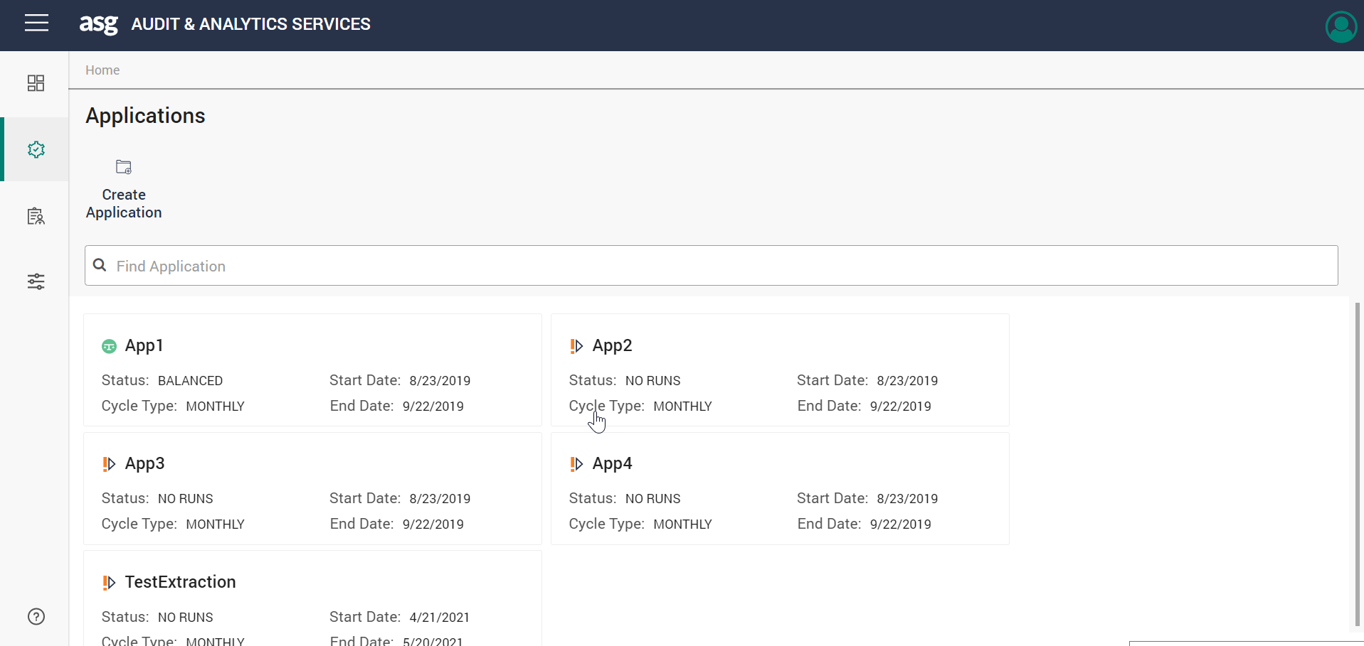

Figure 2: Applications page

1. Click **Create** **Application** button. The **Create Applications** pane appears. (screenshot without App1 appearing)

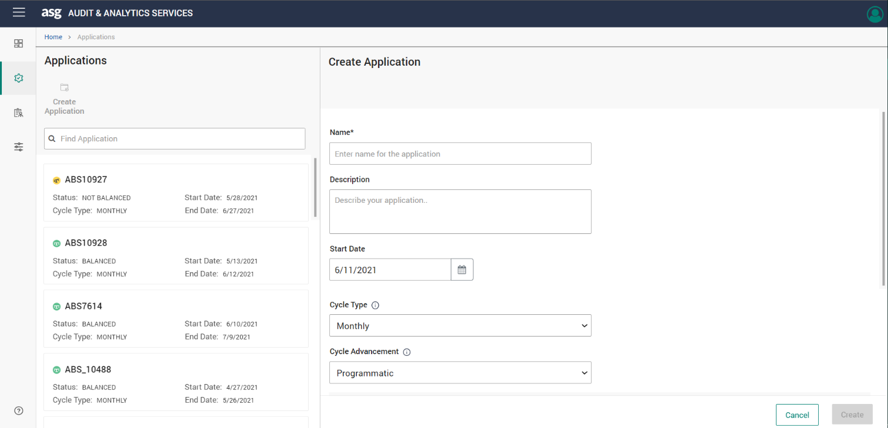

Figure 3: Create Application screen

1. Enter “App1” in the **Name** text box and uncheck the **Lock cycle on advancement** check box.  
   Graphical user interface, application

   Description automatically generated

Figure 4 Entering the Name as “App1”

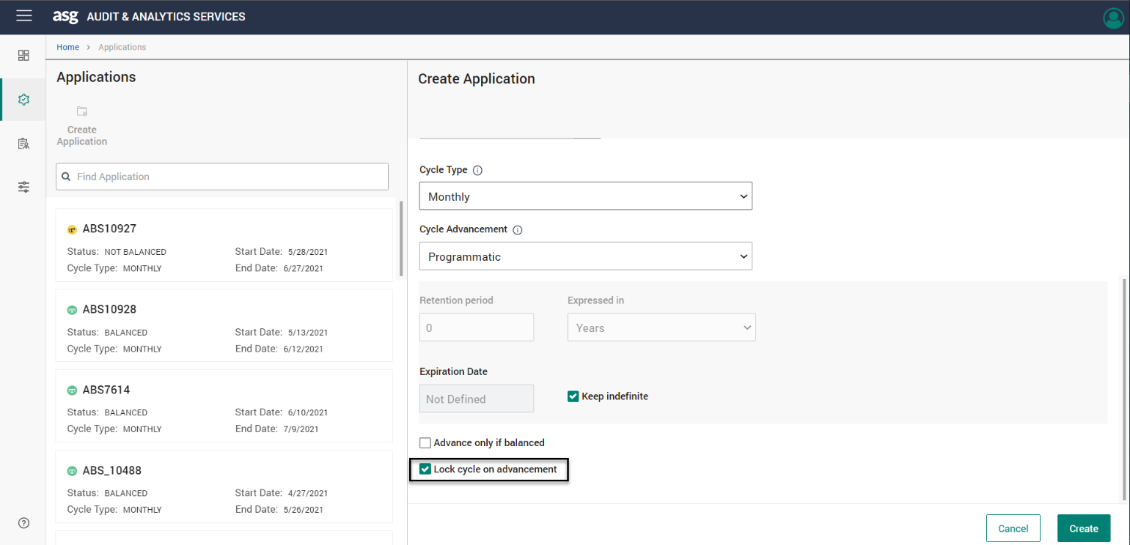

Figure 5 Enabling Lock Cycle on Advancement Check box

1. Click **Create**. An application “App1” is created.

Creating / Viewing the Policy

This is a desktop-based application. A policy which can be used to extract data from the report must be prepared. For demo purposes, a policy of such nature was created for this example (AC001_ RECON.PLC).

1. Launch the Desktop Rule Editor and log in to the application.
2. Go to **Tools** > **Policy Editor**. The **Policy Editor** window appears.  
   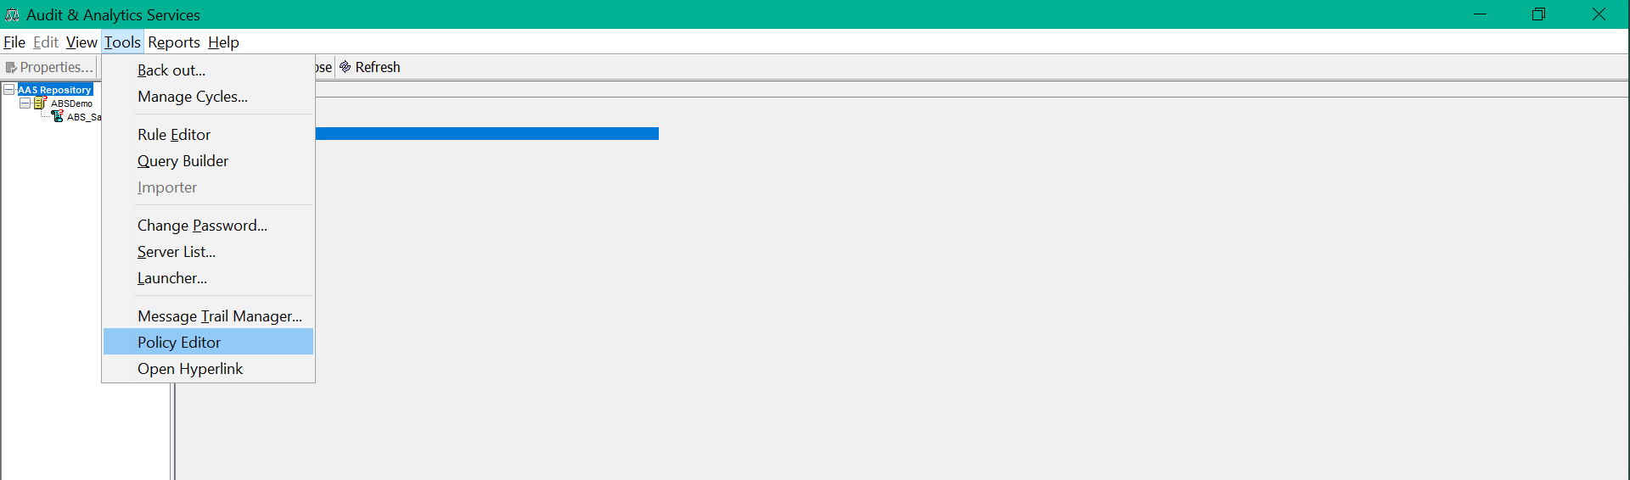

Figure 6 Tools Menu

Figure 7 Policy Editor Window

1. Click **Browse** and select the AC001_POLICY.PLC file.  
   Graphical user interface, text, application

   Description automatically generated

Figure 8 Browse Policy File

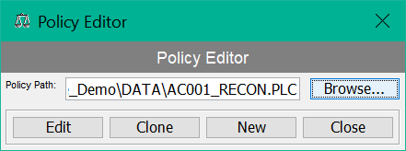

Figure 9 Policy File Selected

1. Click **Edit**. The **Edit Policy** window appears.  
   Graphical user interface, text, application, email

   Description automatically generated

Figure 10 Edit Policy Window

1. Click **Cancel** on the **Edit Policy** window and click **Close** on the **Policy Editor** window.

Creating a Task

1. Select **App1** application from the **Applications** screen.

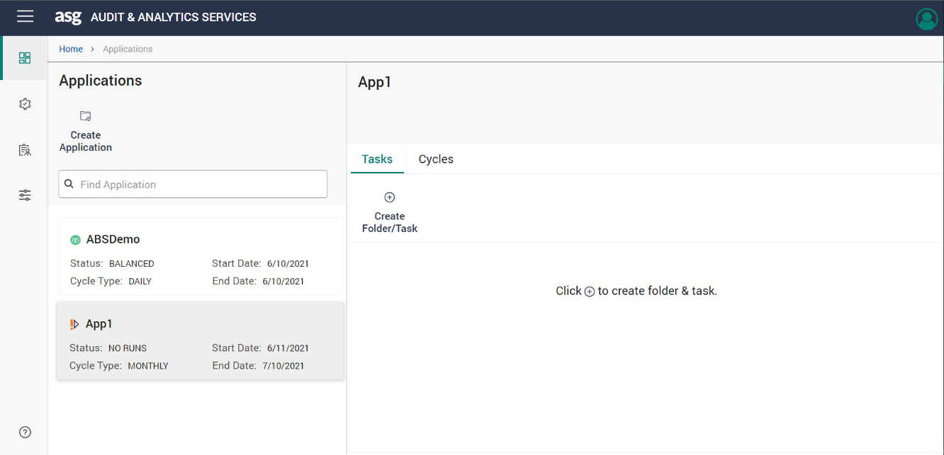

Figure 11: Select App1

1. Click **Create Folder/Task**. The Create Folder/Task pane appears.

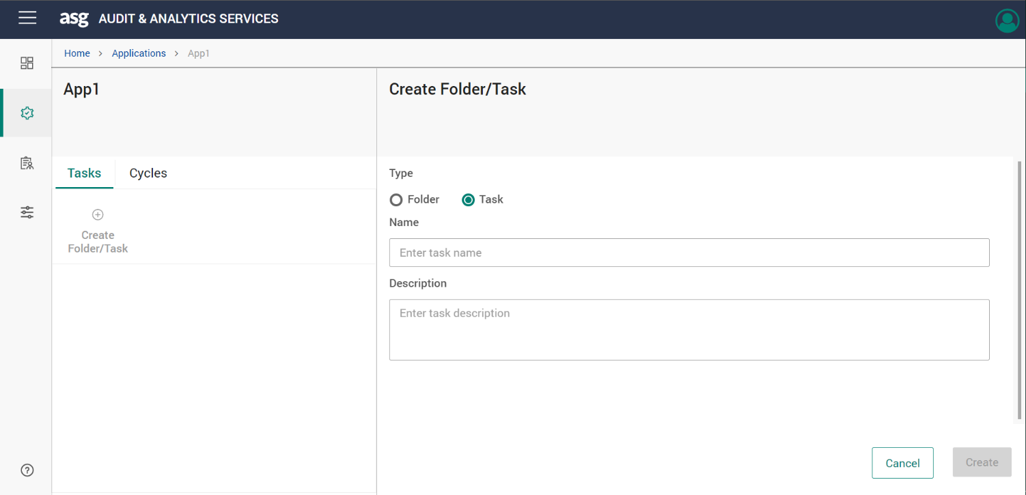

Figure 12: Create Folder/Task button

1. Select the **Task** option and Enter “ReconciliationTask” in the **Name** text box.

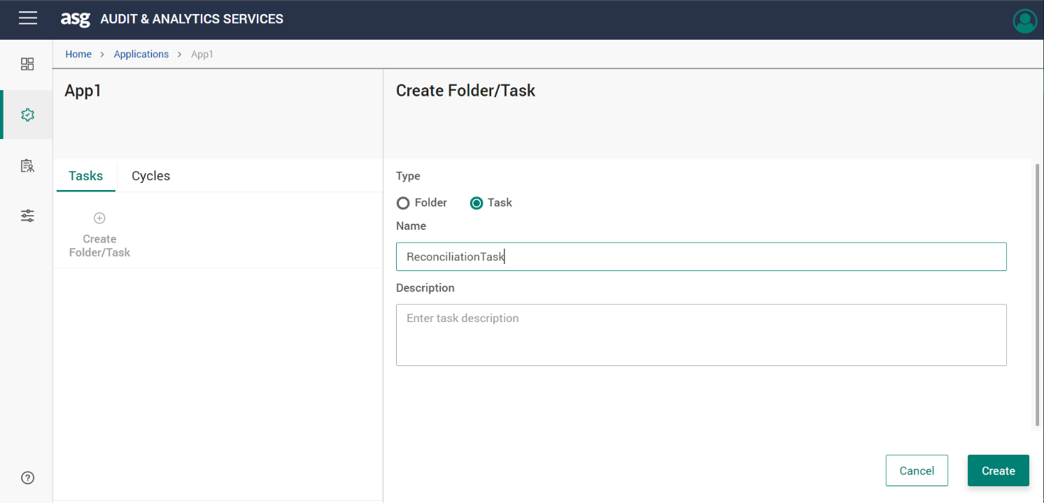

Figure 13: Create Folder/Task screen

1. Click **Create**. The “ReconciliationTask” is created.

Enabling Reconciliation Visualization Option

1. Open the browser and hit the URL: http://{hostname/ipaddress}:{port number}/aaservices/view/. For example, <http://localhost:8079/aaservices/view/>
2. Log in to the application using the username and password.

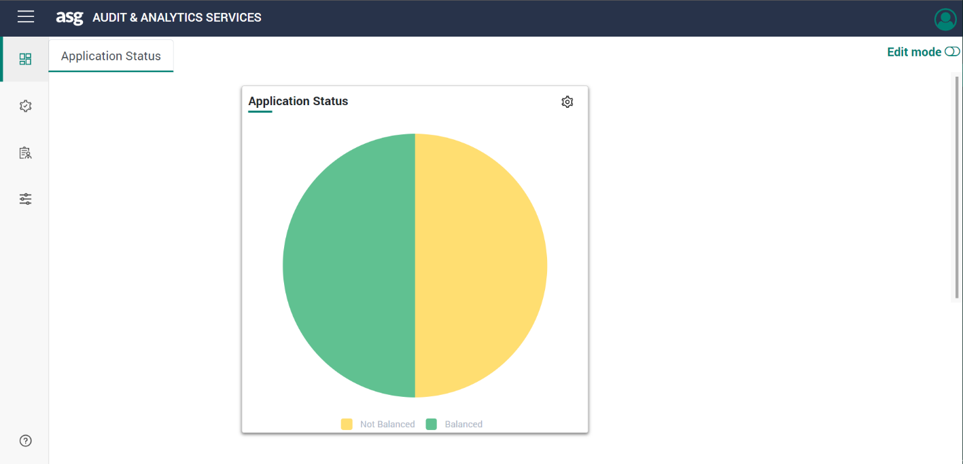

Figure 14: AAS Home

1. Select **File Path** in the **Administration** menu as shown below.

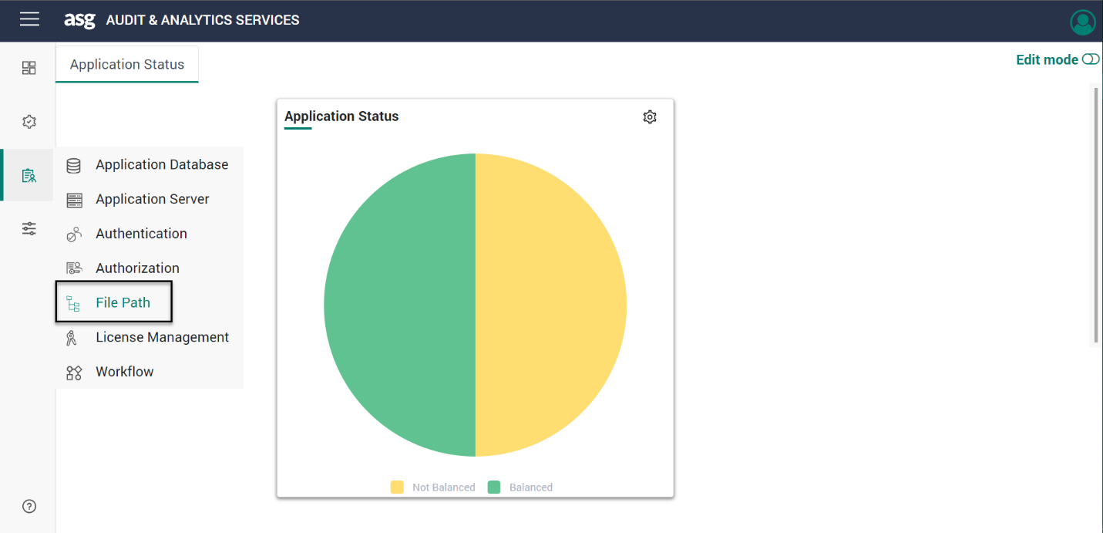

Figure 15: AAS - Administration Tab

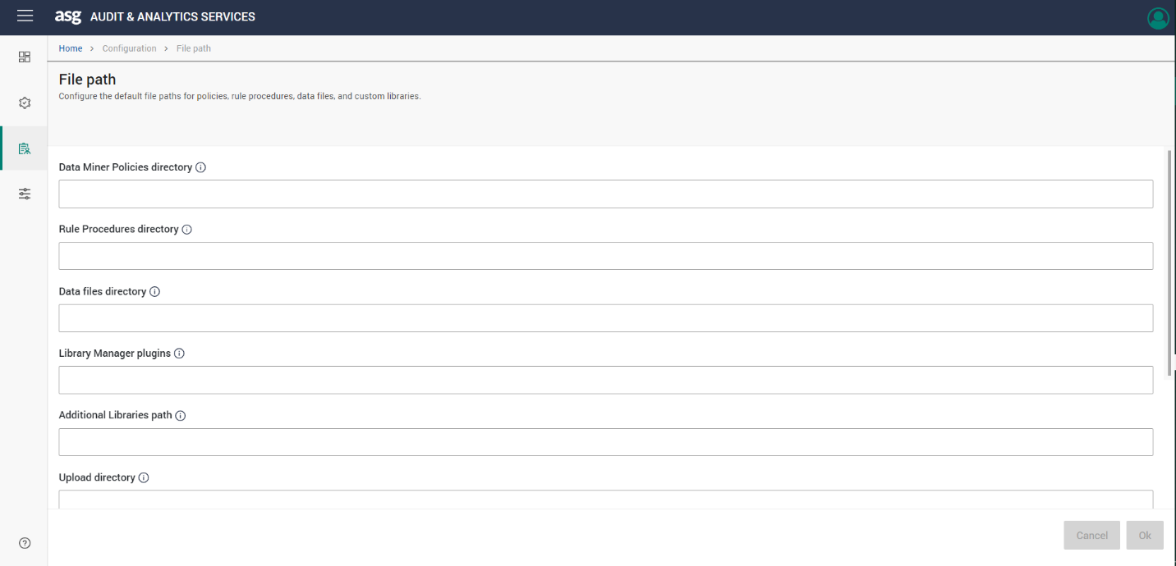

Figure 16: AAS – Select File Path

1. Scroll down to the last and check the **Enable Reconciliation Report** checkbox. Then click **OK**. (Highlight the checkbox in the screenshot)

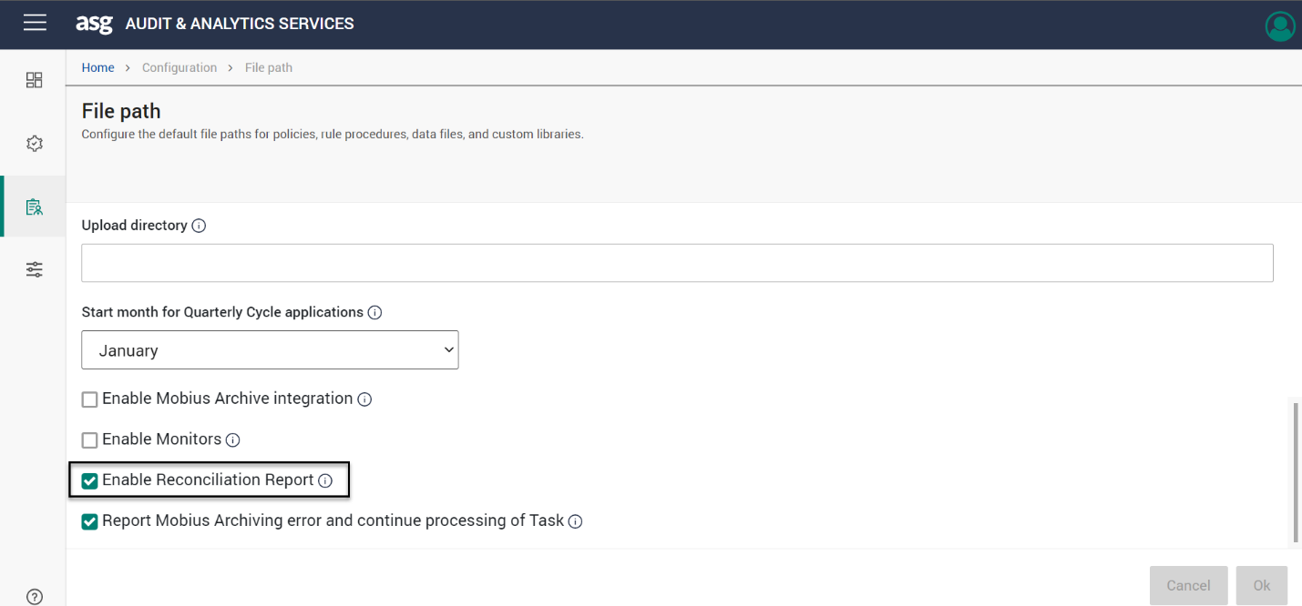

Figure 17: AAS - Enabling Reconciliation Report

1. Restart the *Apache Tomcat Server* and *Mobius RMI Server* services as shown below.

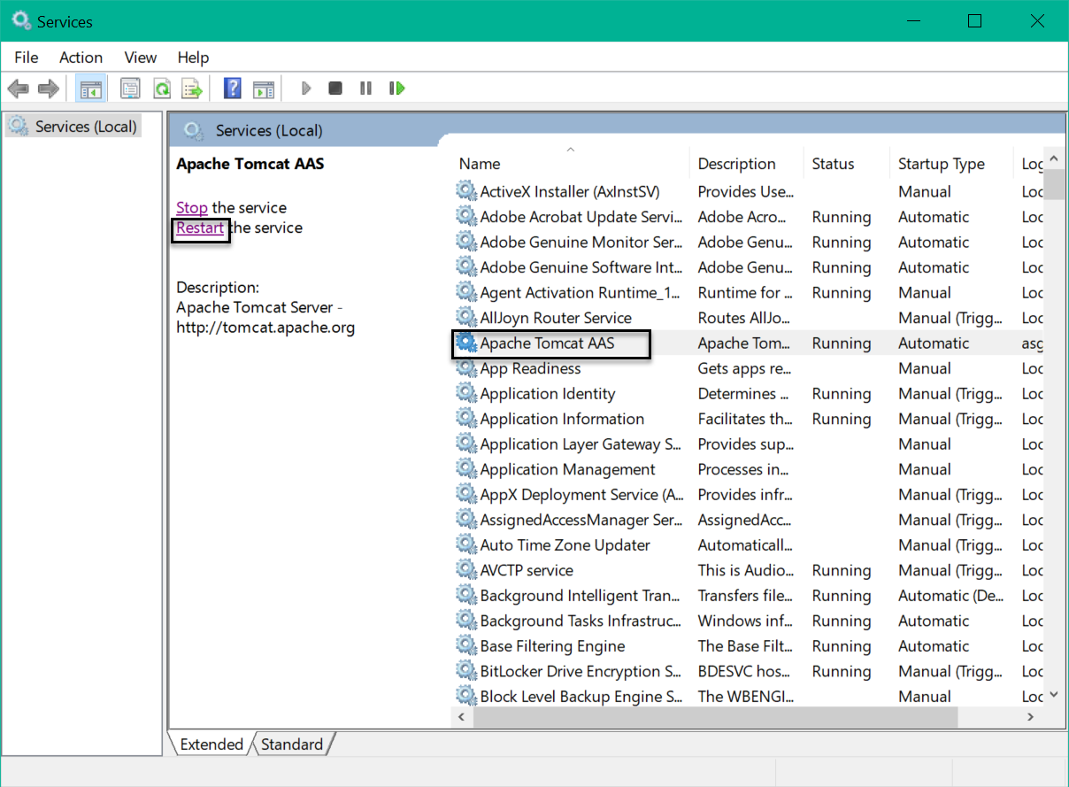

Figure 18 Restarting Apache Tomcat Server

Figure 19: Restarting Mobius RMI Server

Importing Rule Procedure

1. Launch **A&AS Rule Editor and Explorer** desktop application.
2. Go to **Tools** > **Rule Editor**. The Rule Editor window appears.

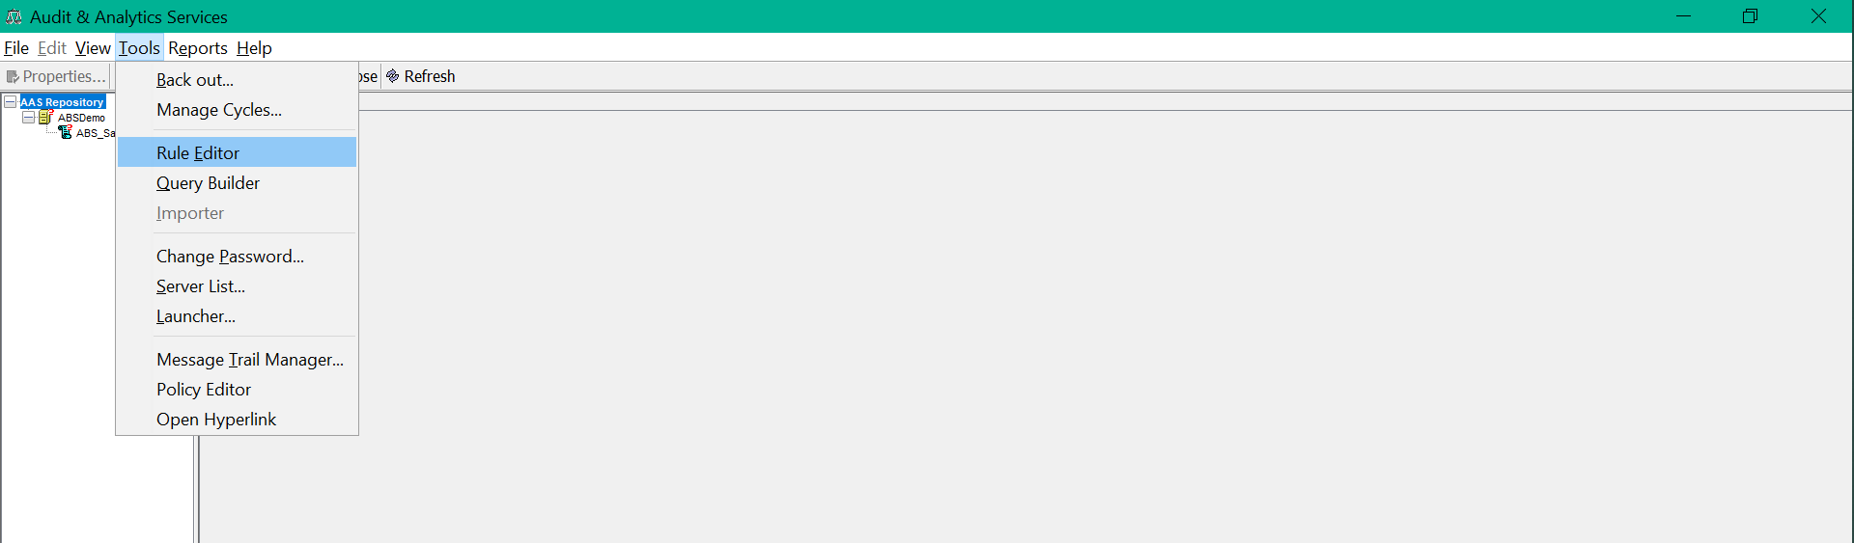

Figure 20: Select Rule Editor

Figure 21 Rule Editor Window

1. Click **Open**. The **Open Rule Procedure** window appears as shown.

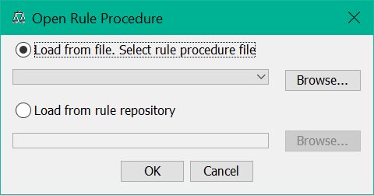

Figure 22: Open Rule Procedure

1. Select **Load from file** option and click **Browse**.  
   Graphical user interface, text, application

   Description automatically generated

Figure 23 Browse Rule Procedure

1. Select the RecRP.xml file and click **OK**. The selected rule procedure will be loaded.  
   Graphical user interface, text, application, chat or text message

   Description automatically generated

Figure 24 Select Rule Procedure

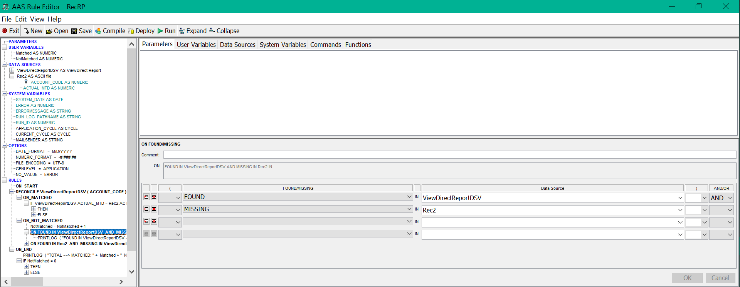

Figure 25: Rule Procedure Loaded

* A Data Source to be used as an input report file must be defined.

1. Expand **DATA SOURCES** and select **ViewDirectReportDSV AS ViewDirect** Report item. We see a ViewDirect Report Source type that will use \Samples\2-Reconciliation_Rule_Procedure_Demo\DATA\AC001_RECON.PLC policy to extract data from the file \Samples\2-Reconciliation_Rule_Procedure_Demo\DATA\AC001page.rpt.  
   The ACCOUNT_CODE and ACTUAL_MTD fields will be extracted from the report.

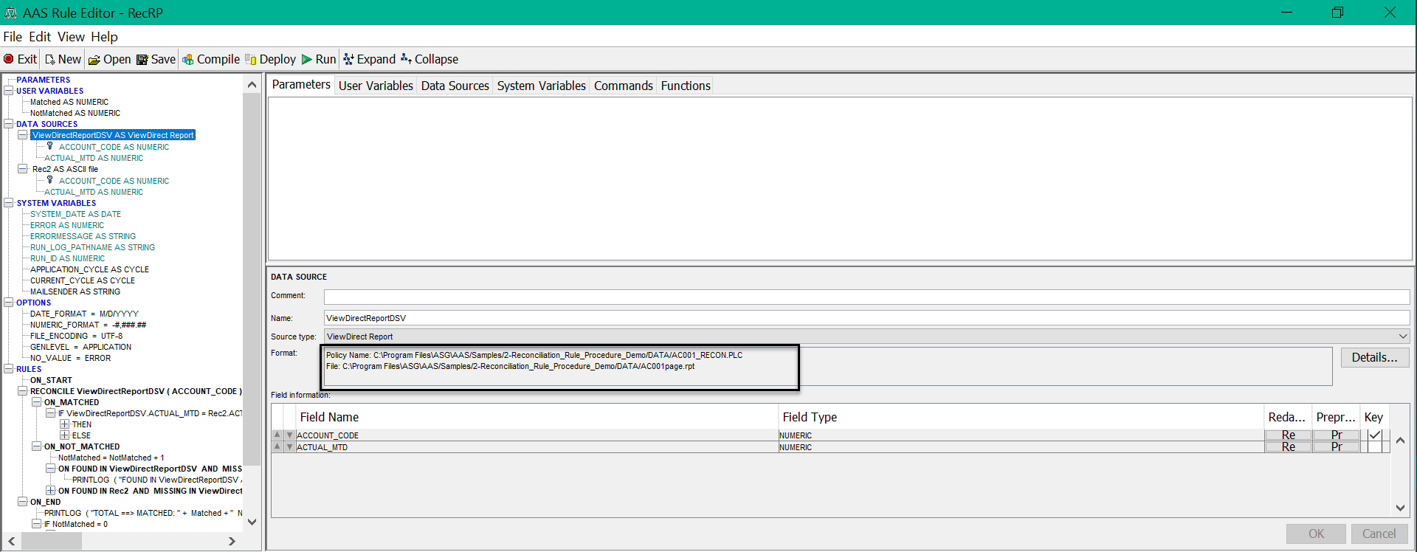

Figure 26: Primary Data Source

1. Select **Rec2 AS ASCII file**.

Figure 27: Rec2 AS ASCII file selection

We can see an ASCII file Source type that will read data from the \Samples\2-Reconciliation_Rule_Procedure_Demo\DATA\rec2.txt file.  
The fields ACCOUNT_CODE and ACTUAL_MTD fields will be used from the file.

Figure 28: Defining the User Variables.

1. After defining the variables, add processing rules. Expand RULES to see a list of rules. Select the first active rule ON_START ACT_TOTAL that has a simple assignment command.

Figure 29: First Active Rule

1. Expand the **Rules** item to see the first active rule RECONCILE that will process ACCOUNT_CODE keys from the report and the file. The RECONCILE rule has the following two cases:
   * ON_MATCHED - In this case, a value of ACTUAL_MTD fields will be compared and then an appropriate match counter will be increased.
   * ON_NOT_MATCHED - In this case, the data sources will be checked for presence and absence on exact ACCOUNT_CODE in a data source.

At the end, a summary report of Matched and NotMatched counters will be printed, and an error status is returned if NotMatched counter is not 0.

Deploying Rule Procedure

1. Click **Deploy** on the **AAS Rule Editor** window.   
   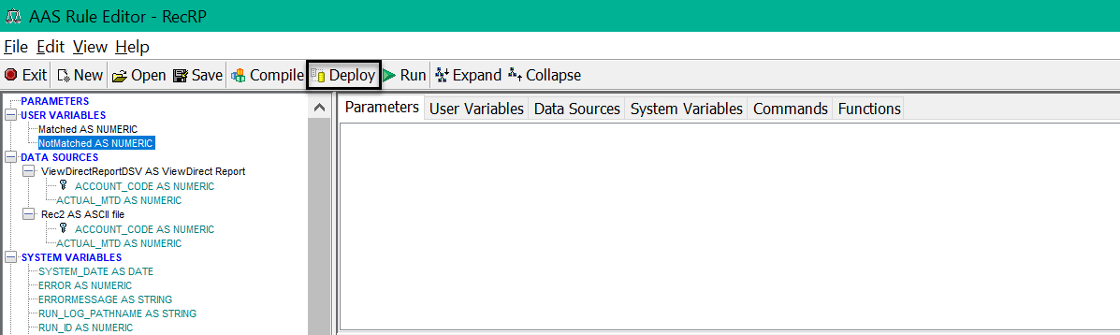

Figure 30 Click Deploy

1. The **Deploy RP** **to Task in ABSServer Configuration** dialog box appears. Choose **App1/BalancingTask** from the name drop-down list and Click **OK**.

Figure 31: Deploying RP to Task in ABSServer Configuration dialog box

1. The AAS will now deploy the Rule Procedure. Click **OK** and close the Rule Editor window.
2. A success message will appear on completion of the deployment.

Figure 32: Deployment Completion

Viewing Run Status and Logs

1. After deploying the Rule Procedure, click **OK**. Close the **Rule Editor** window
2. Open the browser and hit the URL: *http://*{hostname/ipaddress}:{port number}*/aaservices/view/*. For example, <http://local>host:8079/aaservices/view/.
3. Log in to the application using the username and password.
4. Select the “App1” application and select “ReconciliationTask”.
5. Click **Run**. A run logged with its status and message appears.

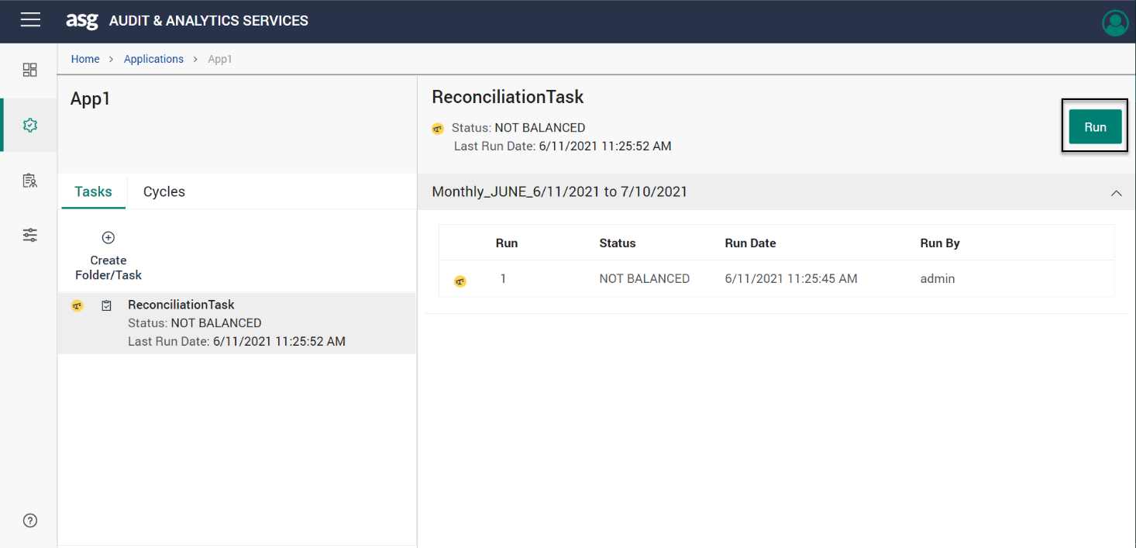

Figure 33: Run ReconciliationTask

1. Check the **Run Log** or **Trace Log** and click **Download** to download the logs.

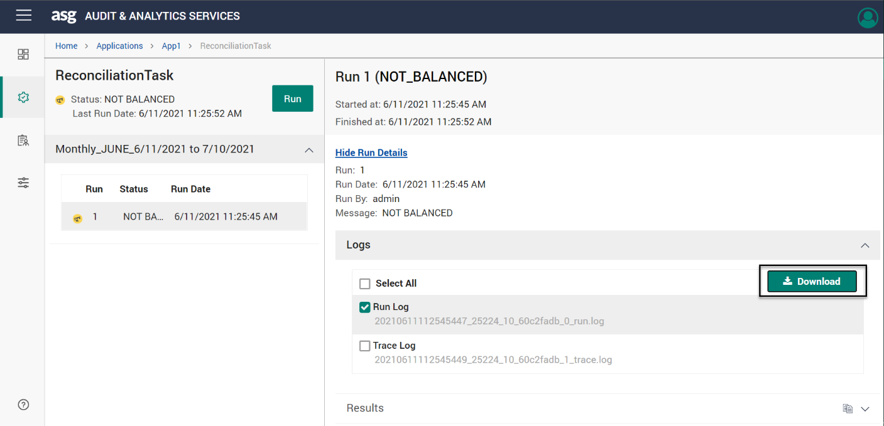

Figure 34: Run/Trace Log

1. Open the downloaded log files to view the log report.

|  |
| --- |
| 14:37:48 --  Rule procedure RecRP  Type Reconciliation  Application App1  Cycle 20190301  Run 1  Mode Production  Execution date 3/14/2019  Run log level 2 (Print)  User ADMIN  14:37:48 --Starting processing  14:37:51 --ACCOUNT_CODE 805001.0 has different ACTUAL_MTD values: ViewDirectReportDSV=2637.0 , Rec2=2630.0  14:37:51 --FOUND IN ViewDirectReportDSV AND MISSING IN Rec2 ==> ACCOUNT_CODE: 865001.0 ACTUAL_MTD: 1246.0  14:37:51 --FOUND IN ViewDirectReportDSV AND MISSING IN Rec2 ==> ACCOUNT_CODE: 905001.0 ACTUAL_MTD: 441.0  14:37:51 --FOUND IN Rec2 AND MISSING IN ViewDirectReportDSV ==> ACCOUNT_CODE: 905009.0 ACTUAL_MTD: 441.0  14:37:52 --TOTAL ==> MATCHED: 16.0 NOT MATCHED: 4.0  14:37:52 --RETURN command occurred; code: 12; message: NOT BALANCED  14:37:52 --Processing completed. |

Figure 35: Log Report

1. We can view the following reports from the logs:
   * Account code in the first row has different value in the Report and Test file.
   * Account codes 865001 & 905001 are present only in the Report file and missing in the Test file.
   * Account code 905009 is present in the Test file and missing in the Report file
2. Click on the Reconciliation Report icon in the Results pane as shown below. The Reconciliation Report page shows all the records available.  
   Graphical user interface, text, application, Teams

   Description automatically generated

Figure 36: View Results

1. In the report page, select any of the following options from the Display drop-down list to display the corresponding records.
   1. **All**- This option displays all the records available.  
      Graphical user interface

      Description automatically generated

Figure 37 All Records

* 1. **Missing**- This option displays the records that are in the source but missing in the target and vice versa.  
     Graphical user interface, text, application, email

     Description automatically generated

Figure 38 Missing Records

* 1. **Missing and neighbor**- This option displays the missing records as well as the records present before and after the missing record.  
     Graphical user interface

     Description automatically generated

Figure 39 Missing and Neighboring Records

* You can also use the **Filter** drop-down to select the required field and type the required field name in the **Equals to** text box to filter the results.

Figure 40 Filtering the Results